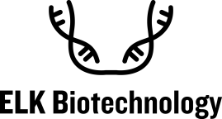
Publication of literature award application form
Applicant information |  | Name |  | Title/Grade
 |  | Phone |  | E-mail
 |  | Date of purchase |  | UuUnits and Laboratories
Information of the paper |  | Title of paper
 |  | Publish a journal |  | Impact Factor
 |  | The first author |  | Corresponding author
 |  | Literature PMID
Product Reference Information |  | Product name |  | Item No.
 |  | Production specifications |  | Reasearch area
 |  | Sample species and tissues |  | Inspection  methods
 |  | Packaging of products |  | Agency
For the use of ELK Biotechnology Product evaluation and suggestions

How to receive rewards |  |  | - Electronic card number (please note below whether to send to email or other means of communication)  - Electronic card number (please note below whether to send to email or other means of communication)  - Issued by the dealer
Mailing address and addressee

Instructions for Giving | - Incomplete information may affect the award.  - If the products quoted in the literature are trial packs, they will not participate in the reward activities.  - The final interpretation of this activity belongs to ELK Biotechnology. For details, please visit www.elkbiotech.com  - ELK Biotechnology will issue rewards within 10 working days after verification.
Signature of the applicant： Date Month Year

